The Major Scale

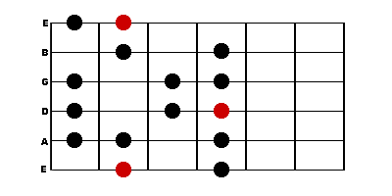

This pattern is moveable up and down the neck – the red dot represents the root

